Project Design Phase-II
Technology Stack (Architecture & Stack)

Date | 30 September 2026
Team ID | SWTID-2026-4717
Project Name | Al weather Wise
Maximum Marks | 4 Marks

Technical Architecture:
The Deliverable shall include the architectural diagram as below and the information as per the table1 & table 2
Example: Order processing during pandemics for offline mode
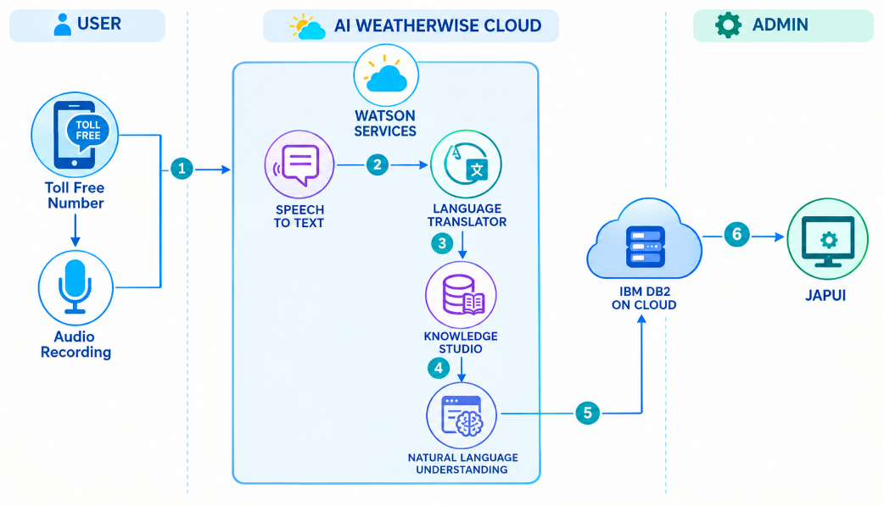
Guidelines:
Include all the processes (As an application logic / Technology Block)
Provide infrastructural demarcation (Local / Cloud)
Indicate external interfaces (third party API’s etc.)
Indicate Data Storage components / services
Indicate interface to machine learning models (if applicable)

Table-1 : Components & Technologies:
S.No | Component | Description | Technology
 | User Interface | How user interacts with application e.g.  Web UI, Mobile App, Chatbot etc. | HTML, CSS, JavaScript / Angular Js / React Js etc.
 | Application Logic-1 | Logic for a process in the application | Java / Python
 | Application Logic-2 | Logic for a process in the application | IBM Watson STT service
 | Application Logic-3 | Logic for a process in the application | IBM Watson Assistant
 | Database | Data Type, Configurations etc. | MySQL, NoSQL, etc.
 | Cloud Database | Database Service on Cloud | IBM DB2, IBM Cloudant etc.
 | File Storage | File storage requirements | IBM Block Storage or Other Storage Service or Local Filesystem
 | External API-1 | Purpose of External API used in the application | IBM Weather API, etc.
 | External API-2 | Purpose of External API used in the application | Aadhar API, etc.
 | Machine Learning Model | Purpose of Machine Learning Model | Object Recognition Model, etc.
 | Infrastructure (Server / Cloud) | Application Deployment on Local System / Cloud  Local Server Configuration:  Cloud Server Configuration : | Local, Cloud Foundry, Kubernetes, etc.

Table-2: Application Characteristics:
S.No | Characteristics | Description | Technology
 | Open-Source Frameworks | List the open-source frameworks used | Technology of Opensource framework
 | Security Implementations | List all the security / access controls implemented, use of firewalls etc. | e.g. SHA-256, Encryptions, IAM Controls, OWASP etc.
 | Scalable Architecture | Justify the scalability of architecture (3 – tier, Micro-services) | Technology used
 | Availability | Justify the availability of application (e.g. use of load balancers, distributed servers etc.) | Technology used
 | Performance | Design consideration for the performance of the application (number of requests per sec, use of Cache, use of CDN’s) etc. | Technology used

